Smart E-Commerce Checkout Workflow
SUBJECT CODE : LC25MCA 205/206 CL01
SUBJECT NAME : ADVANCED CLOUD TECHNOLOGIES
GitHub URL: https://github.com/umamaheswarip24/smart-ecom
SUBMITTED BY :
UMAMAHESWARI P
MG25 - MCA

SUBMITTED TO :
SANTHOSH V KRISHNAN
PROFFESSOR
LEAD COLLEGE ANUTONOMOUS

1. Project Overview
This project implements a cloud-native, microservices-based Smart E-Commerce Checkout System. It demonstrates end-to-end order processing using REST APIs, asynchronous messaging, and persistent database storage without any user interface.
The system mimics real-world e-commerce platforms like Amazon and Flipkart, where the Cart, Payment, Inventory, and Discount services are independent but coordinated. All services communicate through REST API calls and RabbitMQ messaging, and the entire workflow is demonstrated using Postman.

Objective
Connect individual microservices (Cart, Payment, Inventory, Discount Function) and supporting components (RabbitMQ, MySQL) into a complete checkout pipeline that reflects a real-world e-commerce workflow, using only API calls, messaging, and database checks.

2. System Architecture
The architecture follows a microservices pattern where each service is independently deployed in its own Docker container. Services communicate synchronously via REST and asynchronously via RabbitMQ.

Checkout Flow
- Cart Service receives the item and stores it in memory.
- Discount Function validates the discount code (e.g., NEWYEAR) and returns the discount percentage.
- Payment Service processes the payment, applies the discount, and calculates the final amount.
- Payment Service publishes a payment_processed event to RabbitMQ asynchronously.
- Inventory Service consumes the event from RabbitMQ and updates the stock in MySQL.

Communication Types
- Synchronous: REST API calls between Postman and all services
- Asynchronous: RabbitMQ message publishing from Payment Service to Inventory Service

3. Technology Stack

Cart Service
Language: Node.js with Express framework. Port: 3001. The cart service manages items in memory using a simple array. It exposes POST /add to add items and GET /view to retrieve cart contents.

Payment Service
Language: Python with Flask framework. Port: 3002. Handles payment processing with and without discount codes. Connects to RabbitMQ using the Pika library to publish the payment_processed event after every successful payment.

Inventory Service
Language: Java with Spring Boot framework. Port: 3003. Manages product stock using MySQL as persistent storage. Uses Spring Data JPA and Hibernate for database operations. Exposes full CRUD APIs for inventory management.

Discount Function
Language: Node.js with Serverless Framework. Port: 3000. Simulates an AWS Lambda function running locally using the serverless-offline plugin. Accepts a discount code and returns the applicable discount percentage.

RabbitMQ
Acts as the message broker between Payment Service and Inventory Service. Payment publishes events to the events queue. The Inventory consumer listens to this queue and processes the event asynchronously. The management dashboard is accessible at port 15672.

MySQL
Relational database for persistent storage. Contains three tables: stock (inventory items), cart_transactions (cart activity logs), and payments (payment records). Tables are auto-created on startup using init.sql.

Docker and Docker Compose
All six services are containerized using Docker. Docker Compose orchestrates all containers together, manages environment variables, port mappings, service dependencies, and network communication between containers.

4. Project Structure
The project is organized into separate folders for each microservice, a shared deployment folder, and a screenshots folder for documentation.
smart-ecom/
├── cart-service/
│ ├── index.js (Express server - POST /add, GET /view)
│ ├── package.json (Node.js dependencies)
│ └── Dockerfile
├── payment-service/
│ ├── app.py (Flask server - discount logic + RabbitMQ publish)
│ ├── notify.py (Standalone RabbitMQ publisher for testing)
│ └── Dockerfile
├── inventory-service/
│ ├── src/main/java/com/example/inventory/
│ │ ├── InventoryController.java (REST API endpoints)
│ │ ├── Stock.java (Entity/Model)
│ │ └── StockRepository.java (JPA MySQL operations)
│ ├── consumer.py (RabbitMQ event listener)
│ ├── pom.xml (Java/Maven dependencies)
│ └── Dockerfile
├── discount-function/
│ ├── handler.js (Serverless Lambda function)
│ ├── serverless.yml (Serverless framework configuration)
│ └── package.json
├── deploy/
│ ├── docker-compose.yml (Runs all 6 services together)
│ ├── init.sql (Creates MySQL tables on startup)
│ ├── k8s-cart.yaml (Kubernetes deployment for cart)
│ └── nginx.conf (Reverse proxy configuration)
├── screenshots/ (Postman and system screenshots)
└── README.md

5. How to Run the Project

Prerequisites
- Docker Desktop installed and running
- Node.js 18 or above installed
- Python 3.x installed with pip
- Postman installed for API testing

Step 1: Start All Services
Open a terminal in the deploy folder and run the following command:
cd smart-ecom/deploy
docker-compose up --build
This starts all 6 services. Wait until you see all containers running in the terminal output.
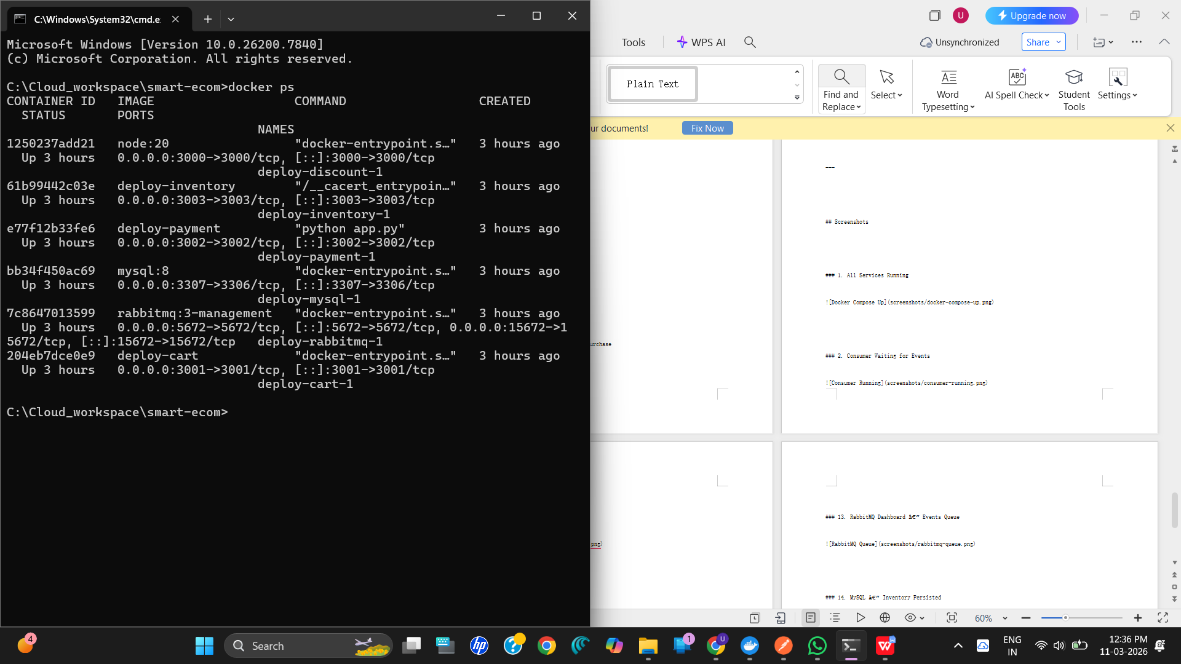

Step 2: Start the RabbitMQ Consumer
Open a second terminal and run the inventory consumer to listen for payment events:
cd smart-ecom/inventory-service
pip install pika requests
python consumer.py
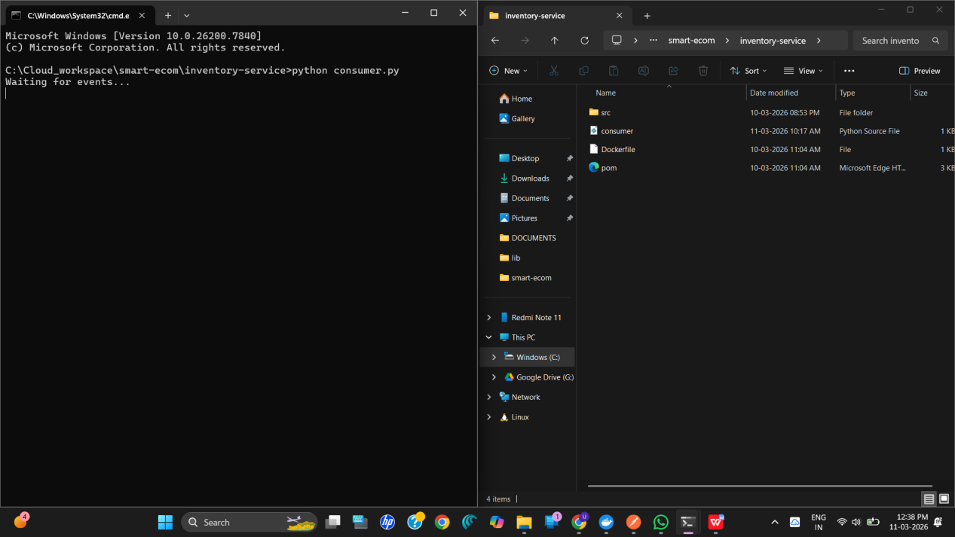

Service URLs
- Cart Service: http://localhost:3001
- Payment Service: http://localhost:3002
- Inventory Service: http://localhost:3003
- Discount Function: http://localhost:3000
- RabbitMQ Dashboard: http://localhost:15672 (guest / guest)
- MySQL: port 3307

6. API Endpoints and Postman Demonstration

6.1 Inventory Service (Port 3003)
POST /inventory/add - Insert New Inventory Item
Request Body:
{ "name": "Mobile", "qty": 20 }
Response:
{ "id": 3, "name": "Mobile", "qty": 20 }
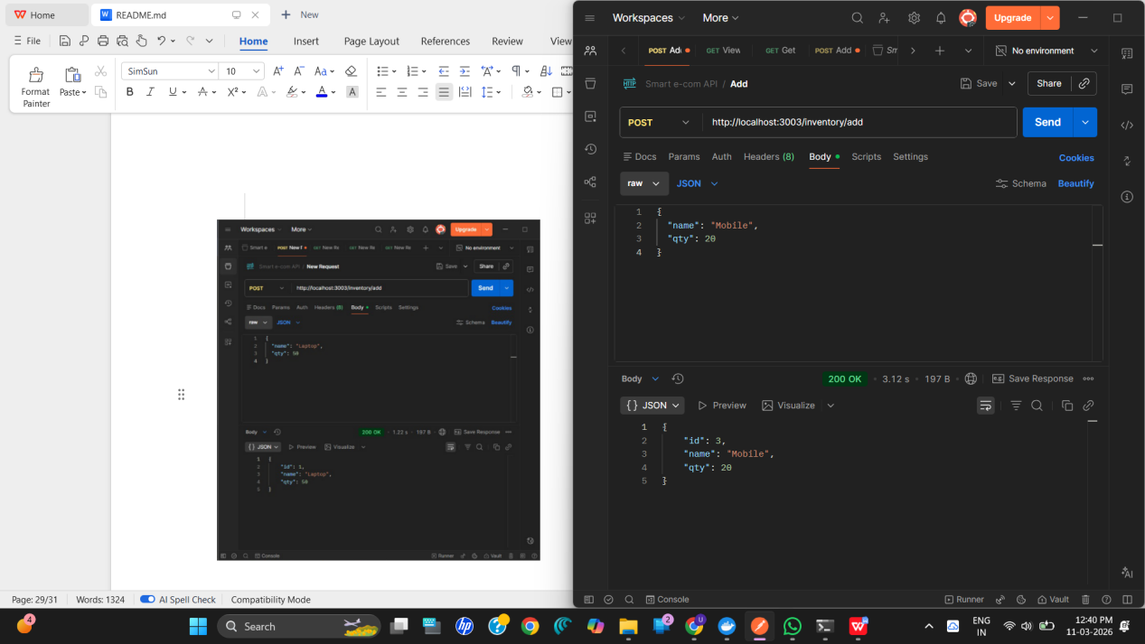

GET /inventory/view - Retrieve All Items
URL: http://localhost:3003/inventory/view
Response:
[ { "id": 1, "name": "Laptop", "qty": 50 }, { "id": 2, "name": "Laptop", "qty": 50 }, { "id": 1, "name": "Mobile", "qty": 20 } ]
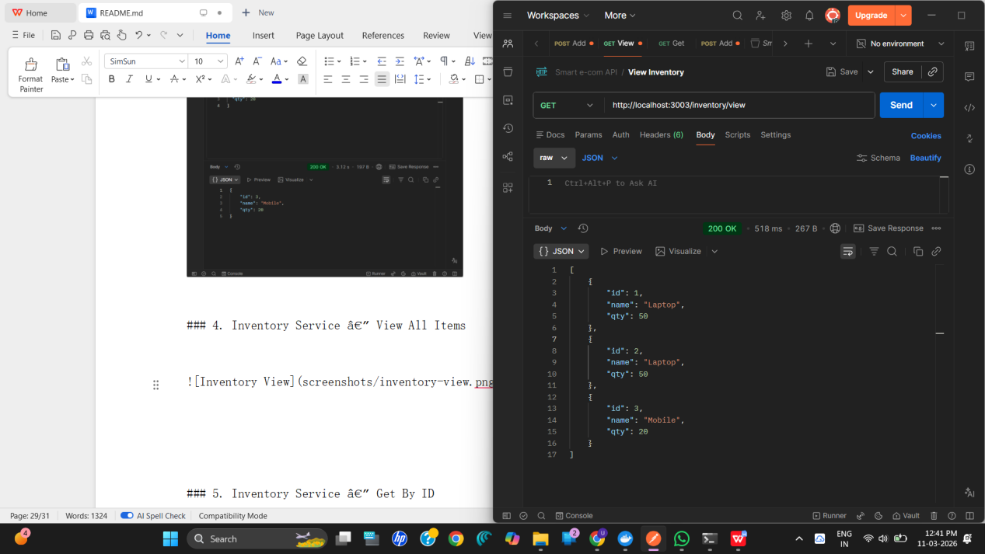

GET /inventory/{id} - Retrieve Specific Item
URL: http://localhost:3003/inventory/2
Response:
{ "id": 2, "name": "Laptop", "qty": 50 }
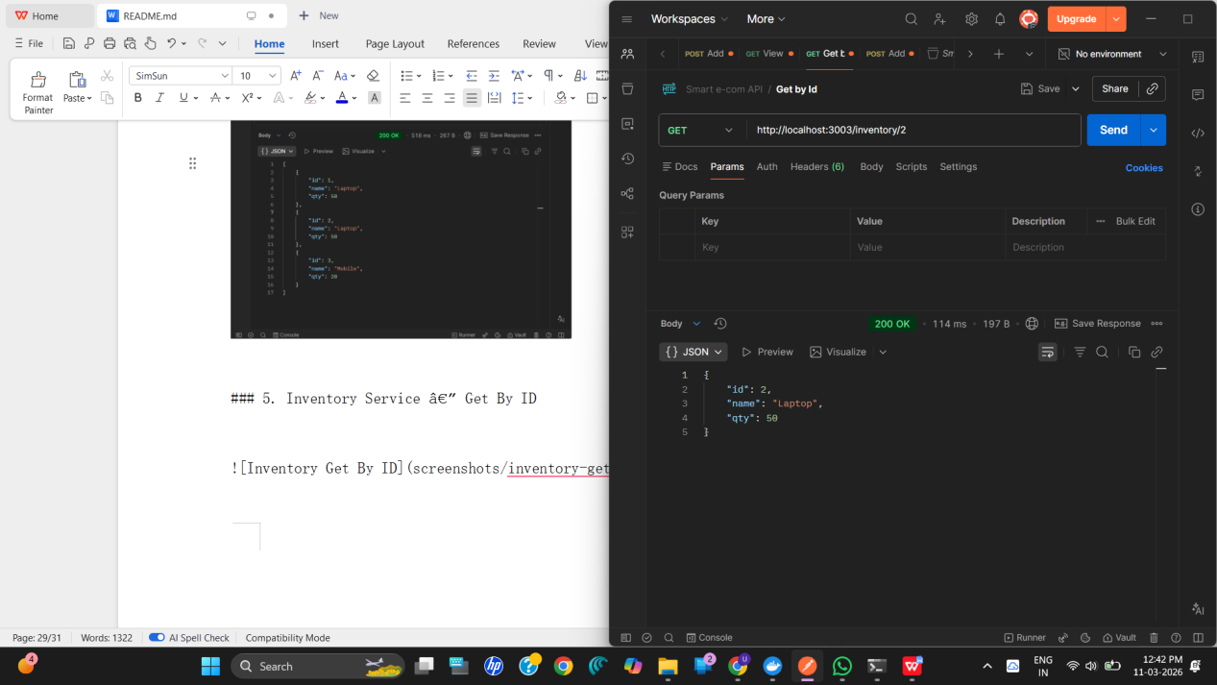
PUT /inventory/update/{id} - Update Quantity After Purchase
URL: http://localhost:3003/inventory/update/1
Request Body:
{ "qty": 45 }
Response:
{ "id": 1, "name": "Laptop", "qty": 45 }

6.2 Cart Service (Port 3001)
POST /add - Add Item to Cart
Request Body:
{ "item": "Mobile" }
Response:
{ "cart": ["PC","Mobile","Mobile"] }

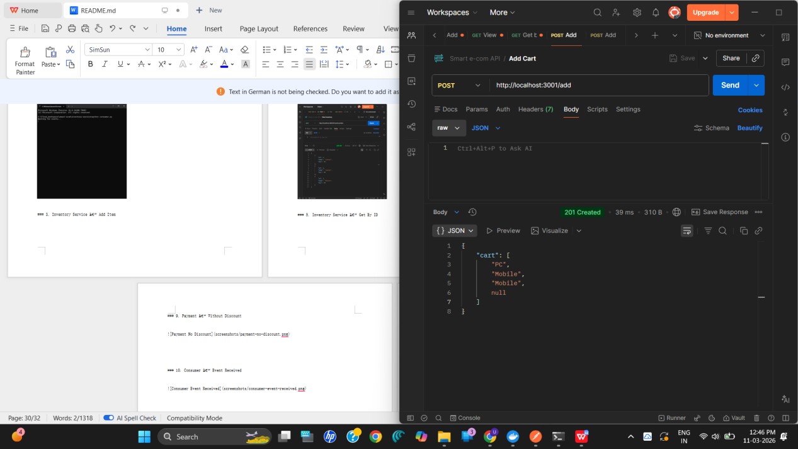

GET /view - View Cart Contents
URL: http://localhost:3001/view
Response:
{ "cart": ["PC","Mobile","Mobile"] }
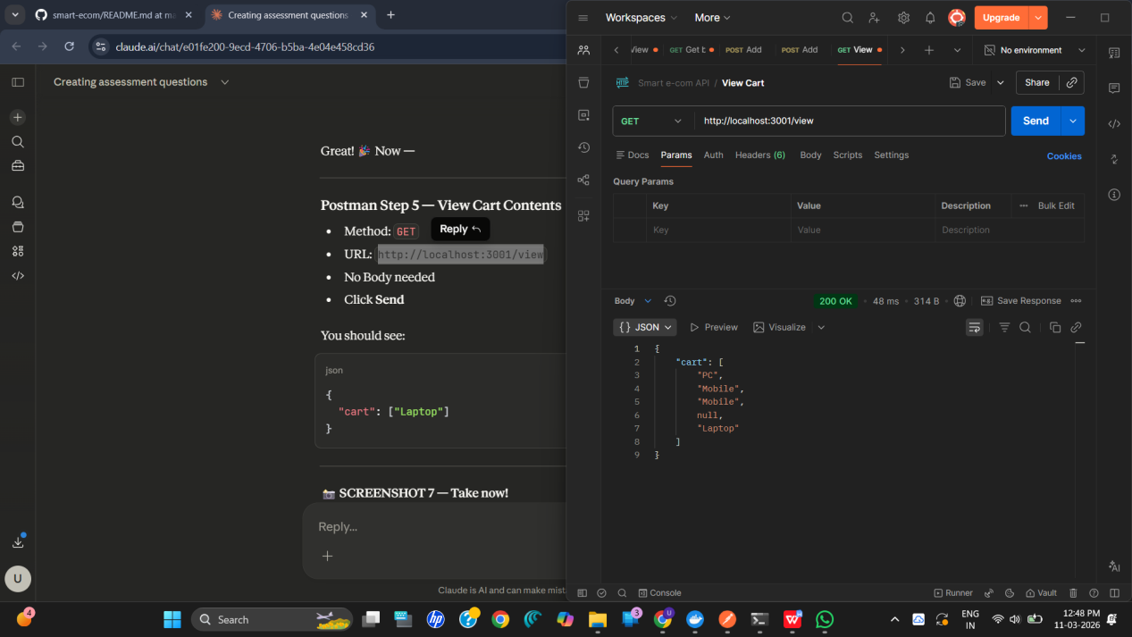

6.3 Discount Function (Port 3000)
POST /dev/apply-discount - Apply Discount Code
Request Body with valid code:
{ "code": "NEWYEAR" }
Response:
{ "discount": 0.2 }

Request Body with invalid code:
{ "code": "INVALID" }
Response:
{ "discount": 0 }

6.4 Payment Service (Port 3002)

POST /pay - Payment WITHOUT Discount
Request Body:
{ "amount": 1000, "method": "card" }
Response:
{ "status": "success", "original_amount": 1000, "discount": "0%",
"final_amount": 1000.0, "method": "card", "event_published": true }
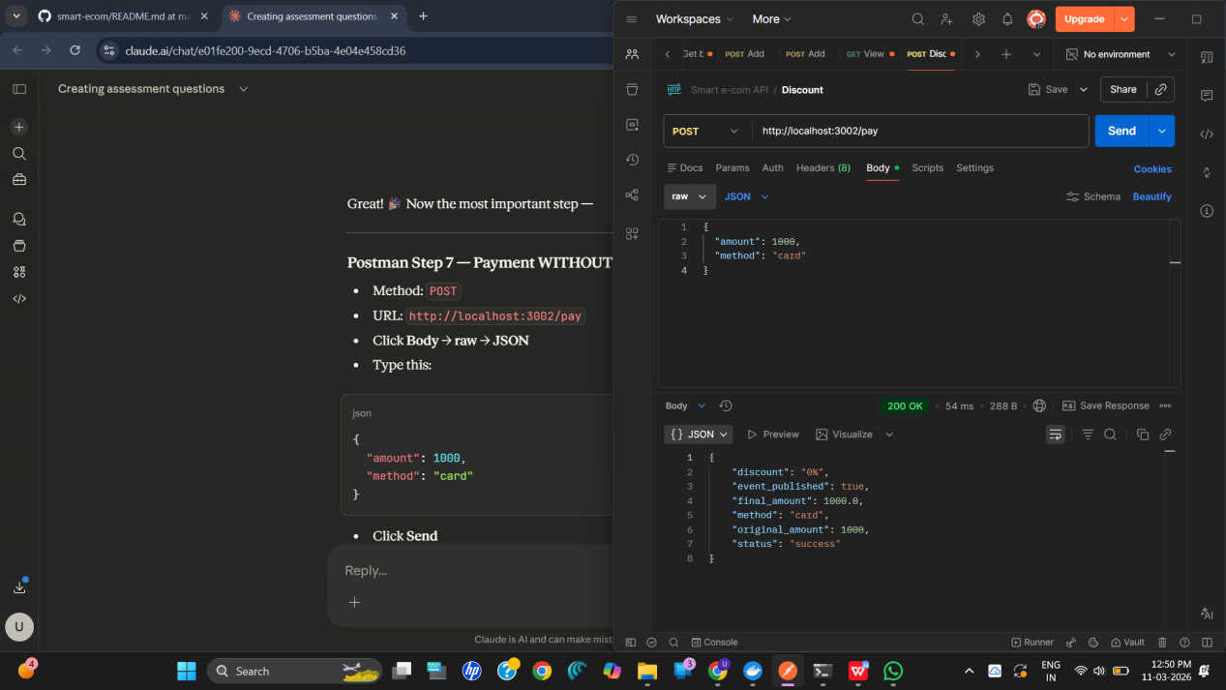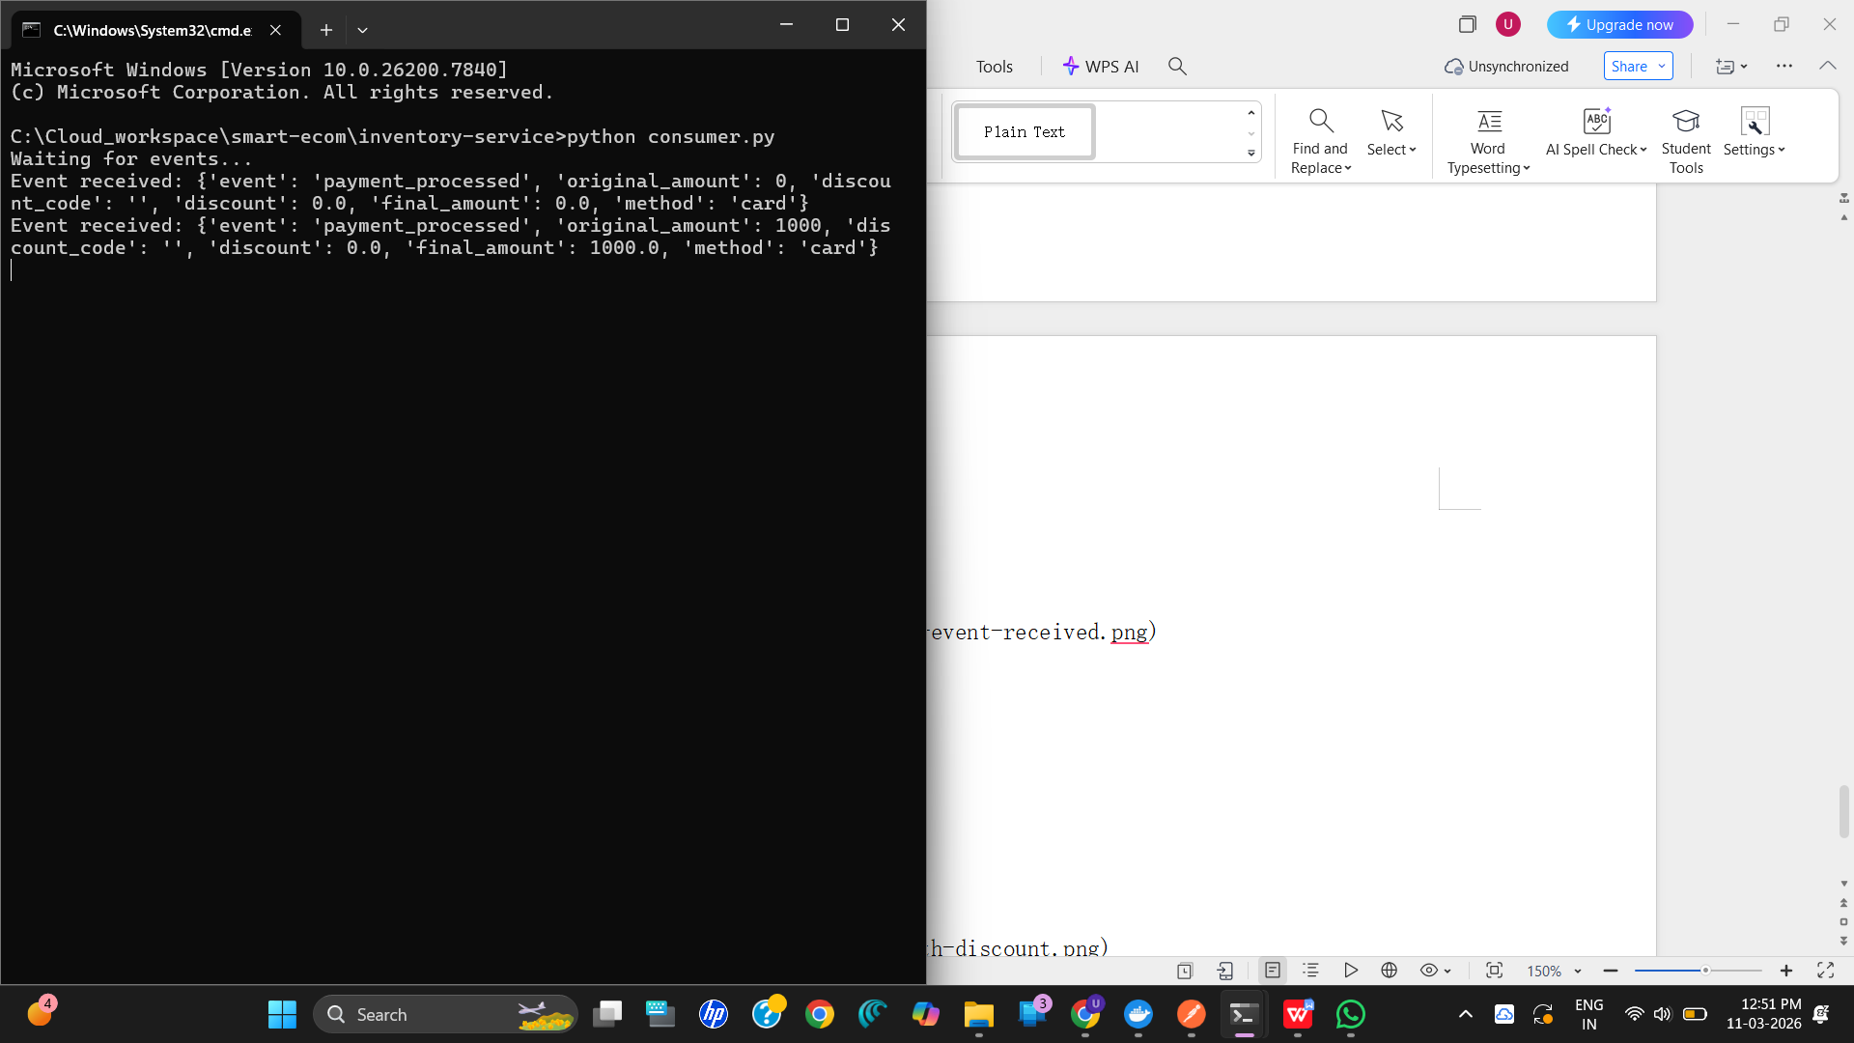

POST /pay - Payment WITH Discount
Request Body:
{ "amount": 1000, "method": "card", "discount_code": "NEWYEAR" }
Response:
{ "status": "success", "original_amount": 1000, "discount": "20%",
"final_amount": 800.0, "method": "card", "event_published": true }
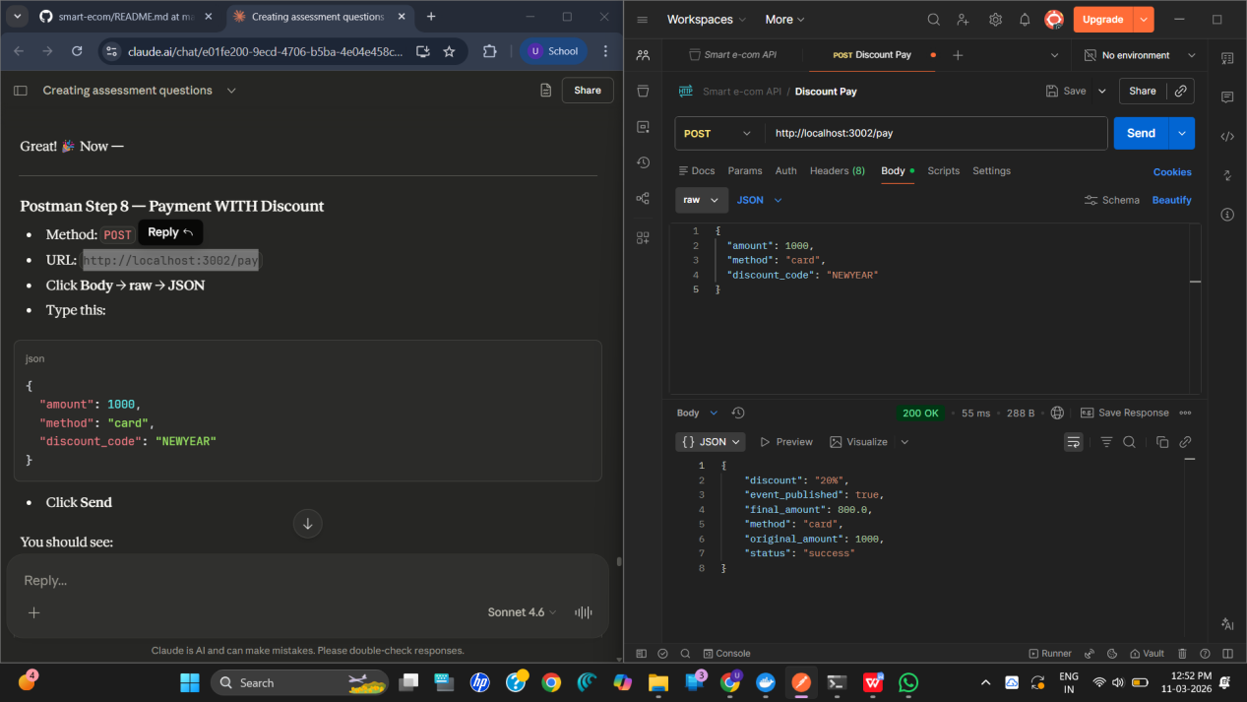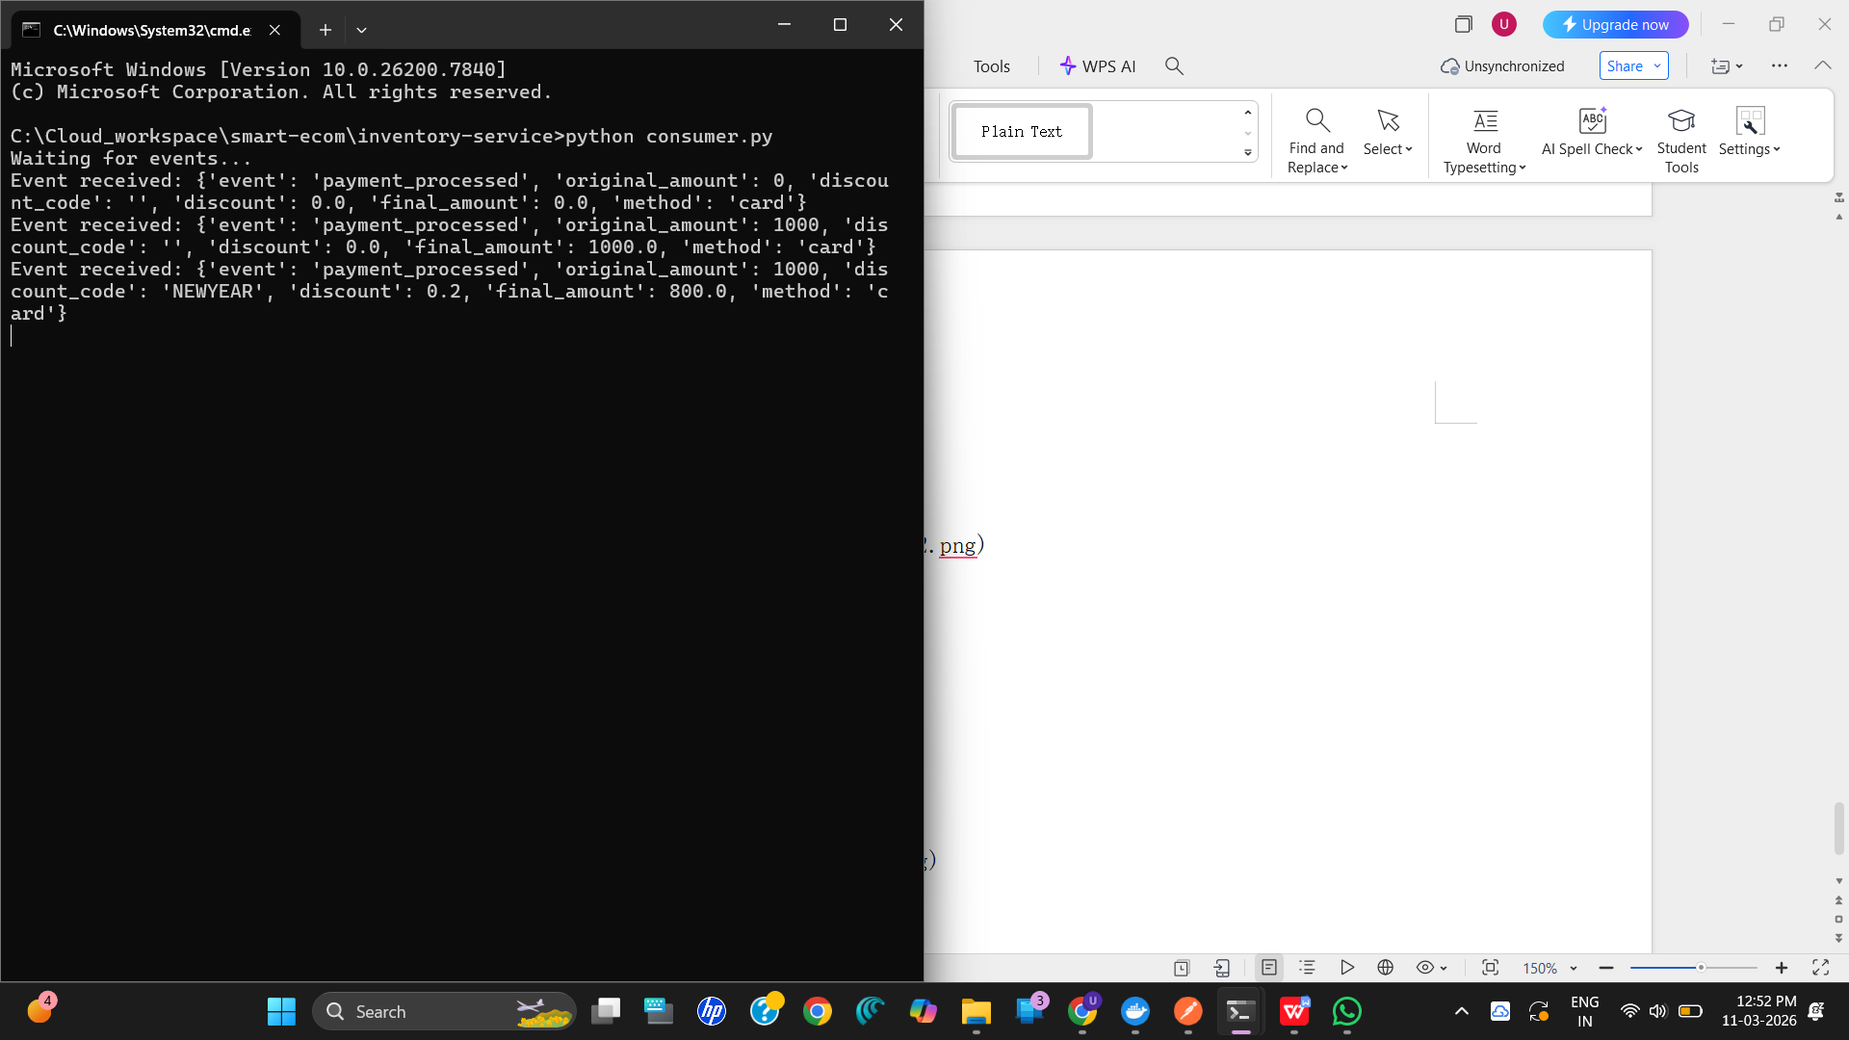

7. End-to-End Checkout Flow Demonstration
The following steps demonstrate the complete checkout choreography as required by the assignment. The flow follows: Cart -> Discount -> Payment -> RabbitMQ -> Inventory.

Step 1: Add Item to Inventory
POST http://localhost:3003/inventory/add with name: Laptop, qty: 50. This confirms the product exists in MySQL before the purchase begins.

Step 2: Add Item to Cart
POST http://localhost:3001/add with item: Laptop. This adds the product to the in-memory cart.

Step 3: View Cart
GET http://localhost:3001/view. This confirms the cart contents before proceeding to payment.

Step 4: Apply Discount Code
POST http://localhost:3000/dev/apply-discount with code: NEWYEAR. This confirms the serverless function returns a 20% discount.

Step 5: Process Payment With Discount
POST http://localhost:3002/pay with amount: 1000, method: card, discount_code: NEWYEAR. The response confirms final_amount: 800 and event_published: true, meaning the payment_processed event was sent to RabbitMQ.

Step 6: Process Payment Without Discount
POST http://localhost:3002/pay with amount: 1000, method: card (no discount code). The response confirms full amount 1000 is charged and the event is still published to RabbitMQ.

Step 7: Verify RabbitMQ Dashboard
Open http://localhost:15672 in browser. Login with guest/guest. Click the Queues tab to see the events queue with processed messages. This proves asynchronous communication is working.
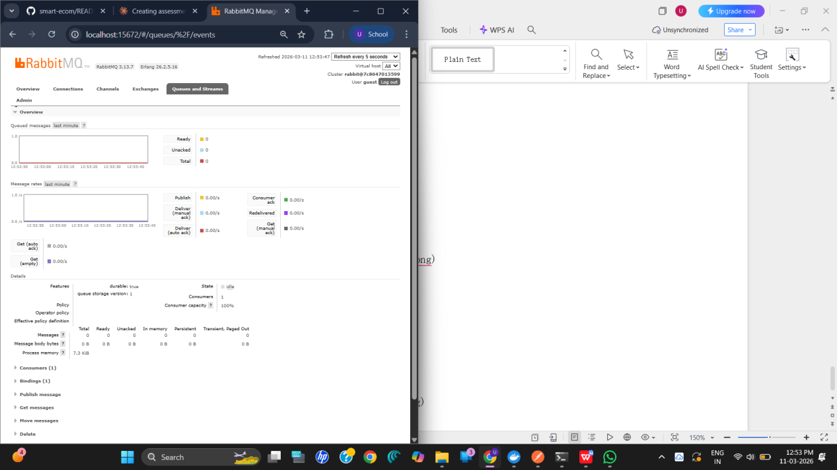

Step 8: Verify Inventory Persisted in MySQL
GET http://localhost:3003/inventory/view. This confirms the inventory data persists in MySQL even after service operations, proving system resilience.
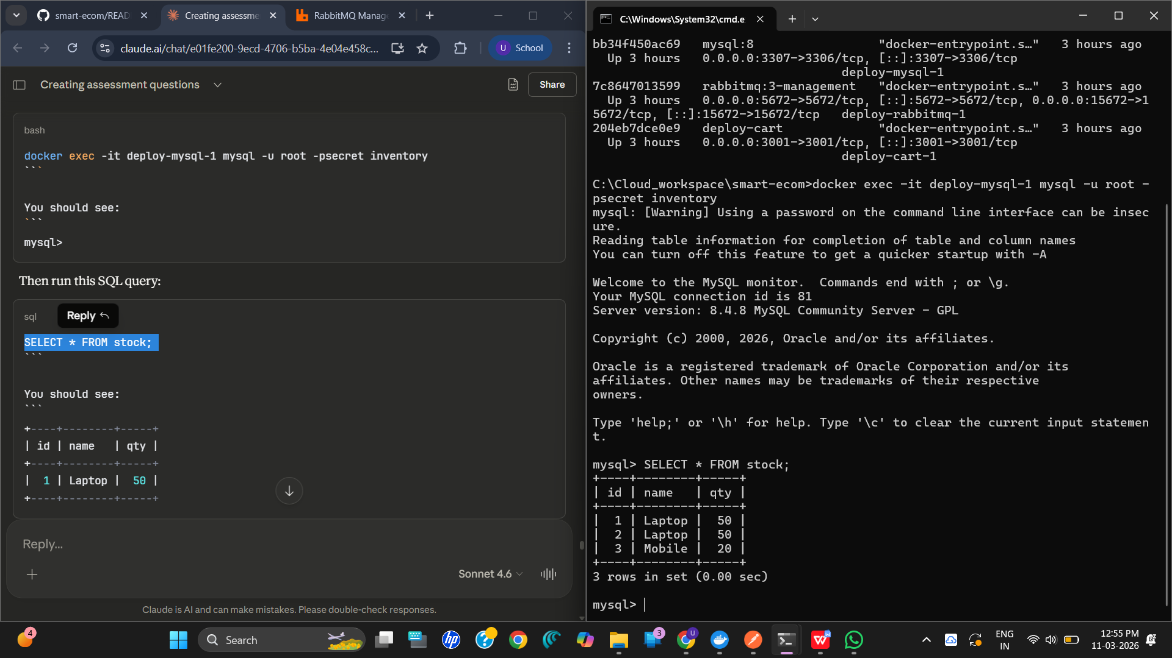

Consumer Terminal
After each payment, the consumer terminal (Terminal 2) prints the received event, confirming that the Inventory Service received the RabbitMQ message asynchronously.
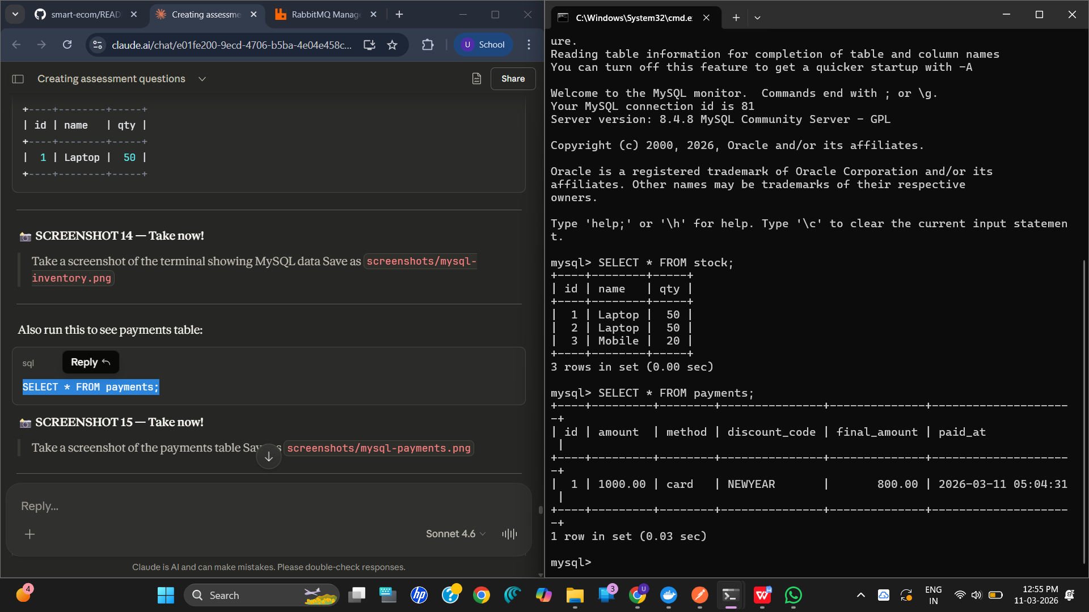

8. System Resilience and Real-World Workflow

Inventory Persistence
All inventory updates are saved to MySQL via Spring Boot JPA. Data survives service restarts because it is stored in the database, not in memory. The init.sql file ensures tables are created automatically on first startup.

Asynchronous Messaging
Payment Service does not call Inventory Service directly. Instead, it publishes a payment_processed event to RabbitMQ. The Inventory consumer picks it up independently. This means if the Inventory Service is temporarily down, the message stays in the queue and gets processed when the service comes back up.

Independent Microservices
Each service runs in its own Docker container on its own port. They can be individually scaled, updated, or restarted without affecting other services. This is the core principle of microservices architecture.

Real-World Similarity
This system mimics the checkout pipeline of platforms like Amazon and Flipkart, where Cart, Payment, and Inventory are separate backend systems that coordinate through events. The project demonstrates both synchronous REST (client to service) and asynchronous messaging (service to service via RabbitMQ).

9. Docker and Kubernetes Deployment

Docker Compose
The docker-compose.yml file in the deploy folder orchestrates all 6 services. It handles build instructions, port mappings, environment variables, service dependencies, and the MySQL initialization script. Running docker-compose up --build starts the entire system with a single command.

Kubernetes
The k8s-cart.yaml file defines a Kubernetes Deployment for the Cart Service with 2 replicas, ensuring high availability. A Kubernetes Service is also defined to expose the cart on port 80, mapping internally to container port 3001.

Nginx
An nginx.conf file is included as a reverse proxy configuration, which can be used to route external traffic to the appropriate microservice based on the request path.

10. Conclusion
This project successfully demonstrates a complete end-to-end Smart E-Commerce Checkout Workflow using microservices architecture. It integrates five independent services (Cart, Payment, Inventory, Discount, and RabbitMQ) with persistent MySQL storage, all containerized using Docker.
The system proves system resilience through MySQL persistence and RabbitMQ asynchronous communication. It reflects real-world e-commerce workflow patterns and demonstrates both synchronous REST and asynchronous messaging as required by the assignment.

